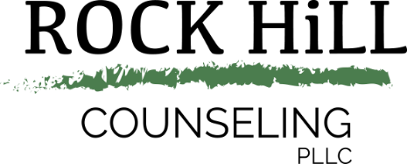

Release of Liability
I understand that Rockhill Counseling, those in contract with Rockhill Counseling, property owners, animal owners and any person or entity working in conjunction with Rockhill Counseling will not be responsible or liable for any damages to person, animal or property at the facility or its grounds, nor will they be responsible or liable for any property lost or destroyed. The undersigned participant/parent/guardian hereby releases Rockhill Counseling, those in contract with Rockhill Counseling, property owners, animal owners and any person or entity working in conjunction with Rockhill Counseling from any and all liability, claims and damages whatsoever (including, but not limited to, costs, expenses, attorney’s fees, medical costs) that might result from damages, injuries, or losses to their person or property during, or in connection with, or arising out of any participation, counseling session, group session, clinic, event, function or visit, whether or not such damages, injuries, or losses result directly or indirectly from the negligent act or omission of such released parties.
WARNING: UNDER TEXAS LAW (CHAPTER 87, CIVIL PRACTICE AND REMEDIES CODE), AN EQUINE PROFESSIONAL IS NOT LIABLE FOR AN INJURY TO OR THE DEATH OF A PARTICIPANT IN EQUINE ACTIVITIES RESULTING FROM THE INHERENT RISKS OF EQUINE ACTIVITIES.
In exchange for counseling services provided and services, I agree that my use, participation and presence on the premises and with any animal, facilities, or equipment used in conjunction with services provided is at my own risk. I further agree to indemnify and hold harmless Rockhill Counseling, those in contract with Rockhill Counseling, property owners, animal owners and any person or entity working in conjunction with Rockhill Counseling, from any and all suits, actions, or claims of any type arising from my use of and/or presence on the premises or participation in the equine activity of such use by myself/parent/guardian, whether or not such claims result directly or indirectly from the negligent act or omissions of the indemnified parties or otherwise.
I acknowledge that involvement with Equine is a high risk activity. I have read this agreement, fully understand its content and agree to the above statements.

